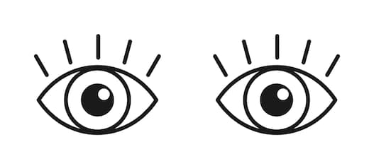Look | What do you see in the data? What stands out to you?
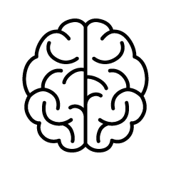  Think | What are you wondering? What do you think has caused the observation(s) you made?
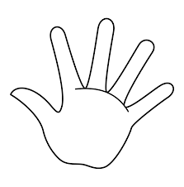  Act | What do you think we should do about what you observed in the data?

Look | What do you see in the data? What stands out to you?
Think | What are you wondering? What do you think has caused the observation(s) you made?
Act | What do you think we should do about what you observed in the data?

